**Spike:** Task 4.P

**Title:** Gridworld Multi-Threaded

**Author:** Mitchell Wright, 100595153

**Goals / deliverables:**

Produce a working Gridworld game, according to the provided specification sheet and develop and understanding of threads and concurrent loops.

Items created during task:

* Code, see: \03 - Spike – Gridworld Multi-threaded\GridWorld\

**Technologies, Tools, and Resources used:**

List of information needed by someone trying to reproduce this work

* Visual Studio 2022
* SourceTree
* GitHub
* Lecture 2.1 – Game Loops & Software Architecture

**Tasks undertaken:**

* Implement Loops
* Use Threads
* Complain About System(“cls”);
* Commit to Git

**What we found out:**

1. Implement Loops:

The separate loops in this program were pretty easy to make. Update is essentially unchanged and render has a quick nap at the end of each loop to prevent flickering.

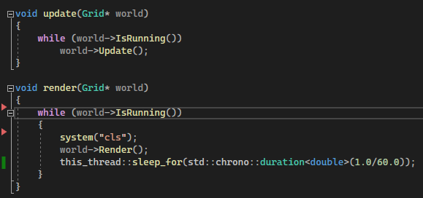

1. Use Threads:

In order to create a thread, this syntax is needed.



Then, once the threads are created, they need to be joined, so that the functions can be run.



Then once the functions in the threads have finished the program ends, much the same as in the previous spike.

1. Complain About System(“cls”):

It’s really slow.

1. Commit to Git:



